<-----------------Algo starts--------------------------->
Algorithm:
For each node, first the node is visited and then it’s child nodes are put in a FIFO queue.
printLevelorder(tree)
1) Create an empty queue q
2) temp_node = root /*start from root*/
/*
3) Loop while temp_node is not NULL
a) print temp_node->data.
b) Enqueue temp_node’s children (first left then right children) to q
c) Dequeue a node from q and assign it’s value to temp_node
<-----------------Algo ends--------------------------->

Here is how program run

1) Before entering the while loop root will have the entire tree which will polled
2)When first time poll() will be called before theat queue will have a single Node class instance which will have entire tree
3)Now when poll will be called root will be polled and two Node class instances will be derived one representing left and one representing right tree
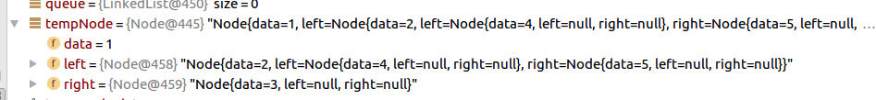
This will be then stored in queue and polled in futher while iteration

4)Now queue will have same data as tempdata

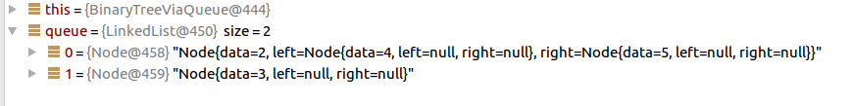
5)Now when poll will be called
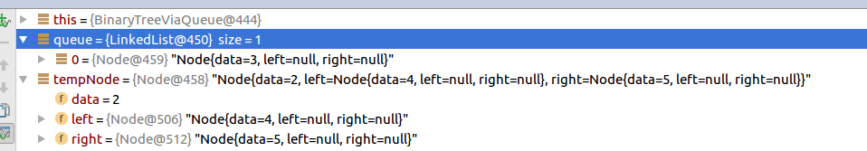
the left sub tree will be removed and queue will only have right subtree

Till here 1,2 has been printed which means these nodes are finsished

6)Now again when the while loop will iterate over it queue will have only leaves left
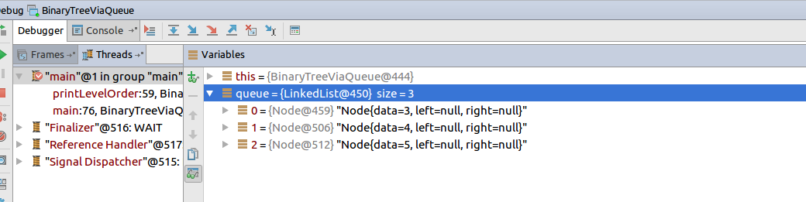
Now 3 will be perinted and tempdata will consists of
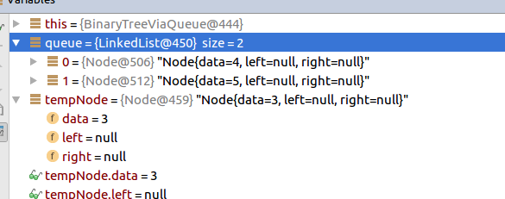

This will continue till all are printed

